**Jgvldgva**

**School of Computing Science & Engineering (SCSE)**

**Case study diagrams for an insurance system**

**Diag 1. Policy inquiry process**

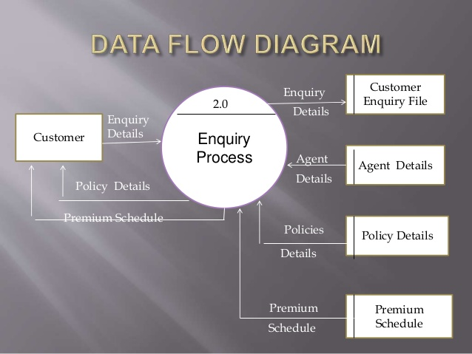

**Diag 2: Customer getting a policy**

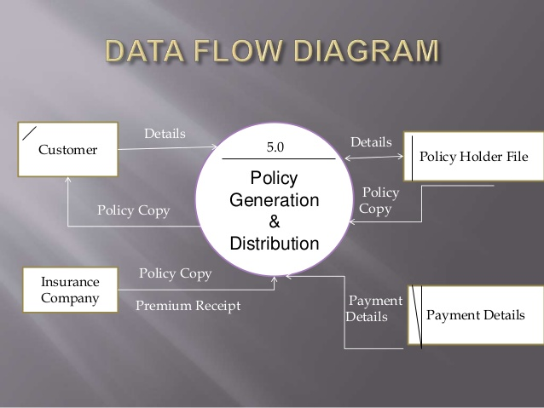

**Diag 3: Customer getting some refund under some claim**

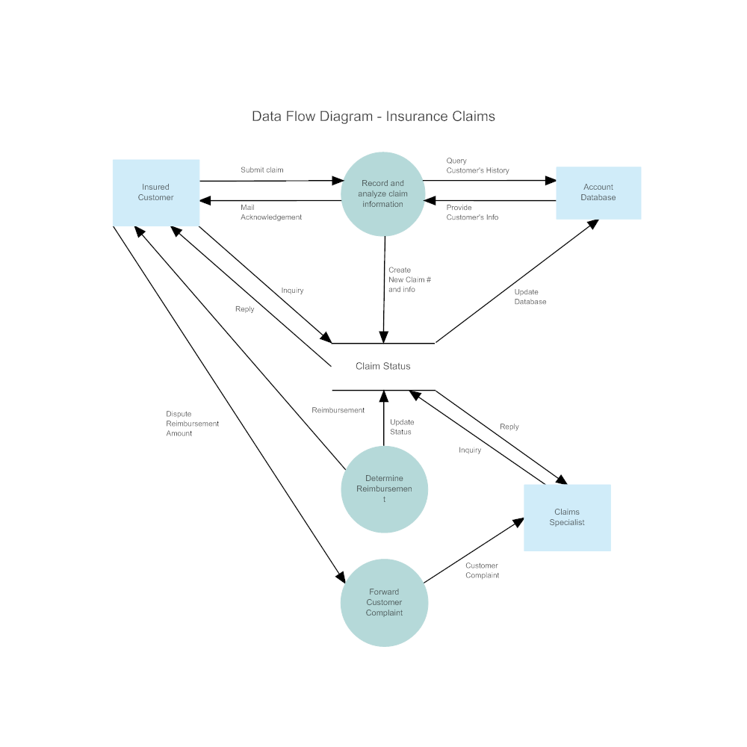

**Diag 4: Detailed diagram involving agents and IRDA [ insurance regulatory authority]**

